Analog Lab 4:

Cascaded Amplifiers

Date: 2023/04/12

Class: 電機二全英班

Group: Group 8

B103105006 胡庭翊

B103105018 劉姵妤

Submitter:

B103105006 胡庭翊

1. Working Project #1: RC-coupled amplifier circuit
2. Measurement Data
3. Without 100uF capacitor on T $R_{1}$

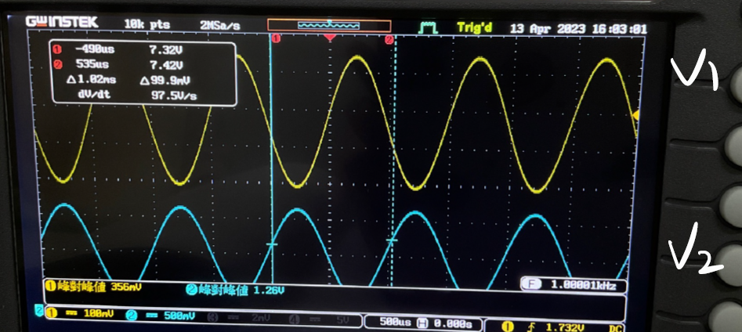

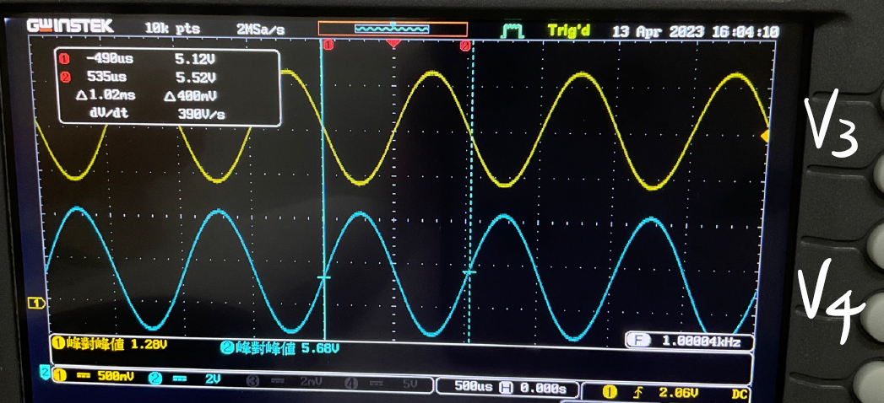

|  |  |  |  |  |
| --- | --- | --- | --- | --- |
| Measurement | $$V_{1}$$ | $$V_{2}$$ | $$V_{3}$$ | $$V_{4}$$ |
| VPP | 0.356V | 1.26V | 1.28V | 5.68V |

$A_{V1}$ = $\frac{V_{2}}{V_{1}}= \frac{1.26V}{0.356V}=$ 3.539V/V;

$A_{V2}$ = $\frac{V_{4}}{V_{3}}= \frac{5.68V}{1.28V}$ = 4.437V/V;

$A_{V}$ = $\frac{V_{4}}{V_{1}}= \frac{5.68V}{0.356V}$ = 15.955V/V

Q: Is $A_{V}= A_{V1}× A_{V2}$?

A: Approximately YES.

3.539 $×4.437=15.70≈15.955$

Q: Is $V_{3}= V_{2}?$

A: Approximately YES.

1.26 $≈1.28$

1. With 100uF capacitor on T $R_{1}$

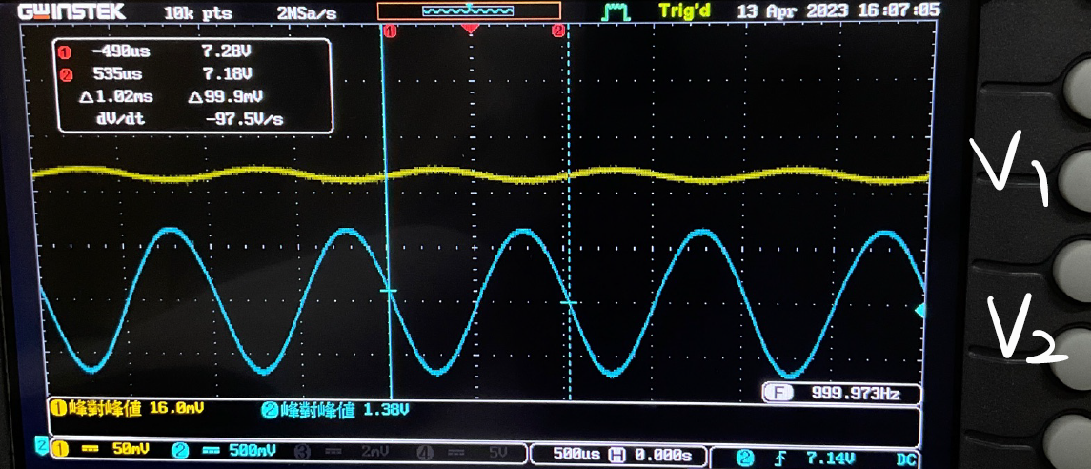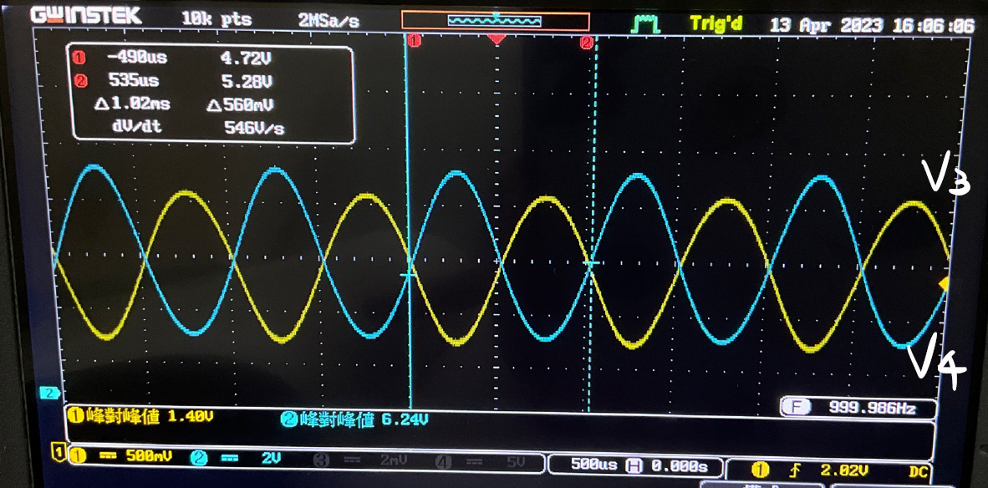

|  |  |  |  |  |
| --- | --- | --- | --- | --- |
| Measurement | $$V_{1}$$ | $$V_{2}$$ | $$V_{3}$$ | $$V_{4}$$ |
| VPP | 0.0168V | 1.38V | 1.40V | 6.24V |

$A_{V1}$ = $\frac{V_{2}}{V_{1}}= \frac{1.38V}{0.0168V}=$ 82.14V/V;

$A_{V2}$ = $\frac{V_{4}}{V_{3}}= \frac{6.24V}{1.40V}$ = 4.457V/V;

$A_{V}$ = $\frac{V_{4}}{V_{1}}= \frac{6.24V}{0.0168V}$ = 371.42V/V

Q: Is $A_{V}= A_{V1}× A_{V2}$?

A: Approximately YES.

82.14 $×4.457=366.097≈371.42$

Q: Is $V_{3}= V_{2}?$

A: Approximately YES.



$≈1.40$

Q: Compare (a) and (b), parallel connect a capacitor on CE amplifier would make the gain increase or decrease?

A: Increase. The total gain AV increase from 15.922 to 371.42 .

1. Simulation Result
2. Without 100uF capacitor on T $R_{1}$



Peak to peak voltage:

$V_{4}$: 8.725V - 2.355V = 6.37V

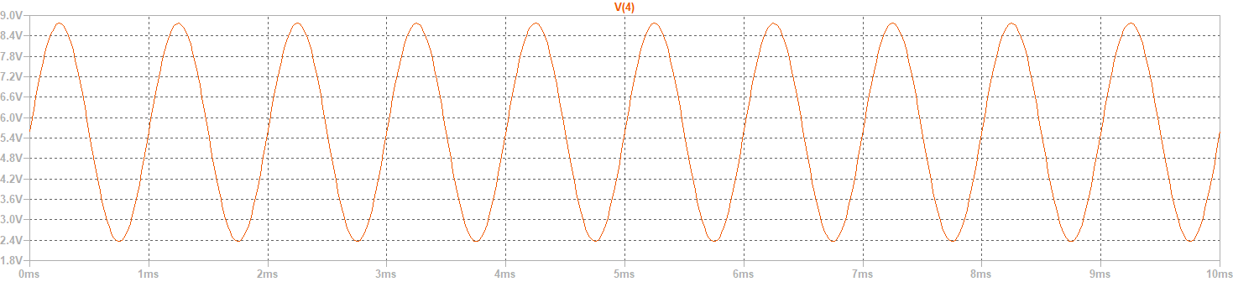

$V_{3}$: 2.7V - 1.3V = 1.4V

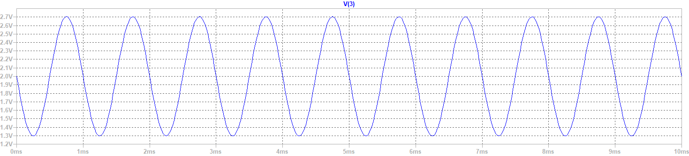

$V_{2}$: 7.96V - 6.6V = 1.4V

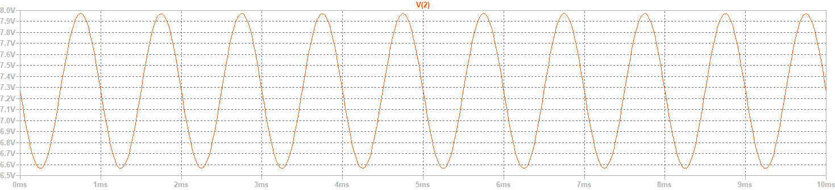

$V_{1}$: 1.855V - 1.46V = 0.395V

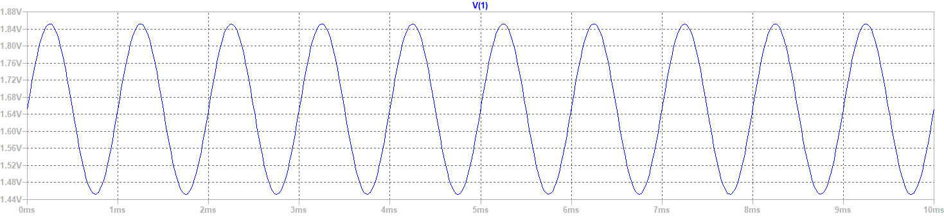

|  |  |  |  |  |
| --- | --- | --- | --- | --- |
| Simulation | $$V_{1}$$ | $$V_{2}$$ | $$V_{3}$$ | $$V_{4}$$ |
| VPP | 0.395V | 1.4V | 1.4V | 6.37V |

$A_{V1}$ = $\frac{V_{2}}{V_{1}}= \frac{1.4V}{0.395V}=$ 3.54V/V;

$A_{V2}$ = $\frac{V_{4}}{V_{3}}= \frac{6.37V}{1.4V}$ = 4.55V/V;

$A_{V}$ = $\frac{V_{4}}{V_{1}}= \frac{6.37V}{0.395V}$ = 16.12V/V

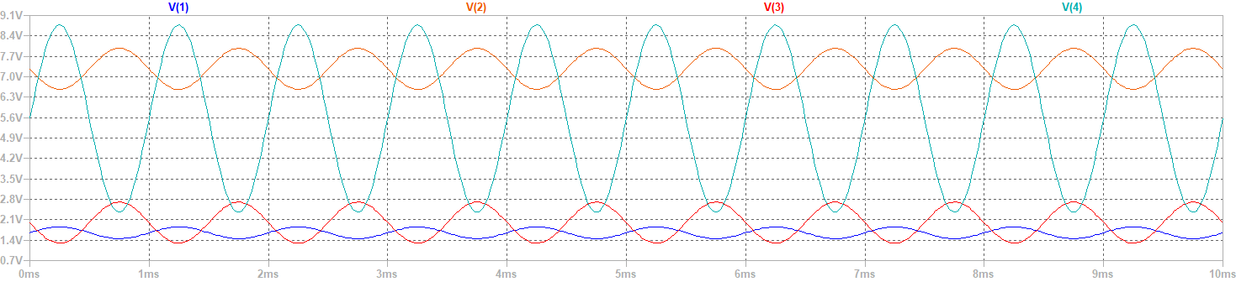

Q: Is $A_{V}= A_{V1}× A_{V2}$?

A: YES.

3.54 $×4.55=16.12$

Q: Is $V_{3}= V_{2}?$

A: YES.

1.4 = 1.4

1. With 100uF capacitor on T $R_{1}$



Peak to peak voltage:

$V_{4}$: 9.12V - 2.34V = 6.78V

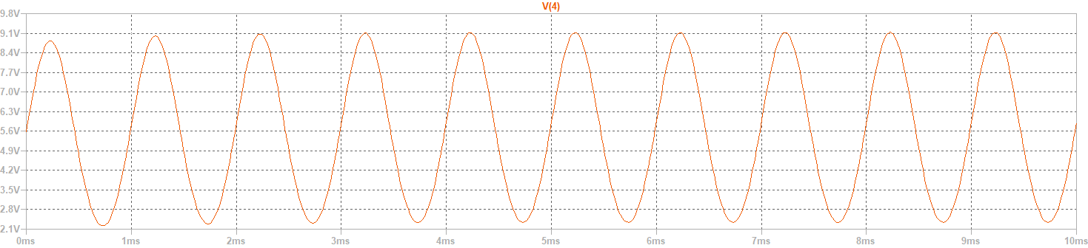

$V_{3}$: 2.73V - 1.33V = 1.4V

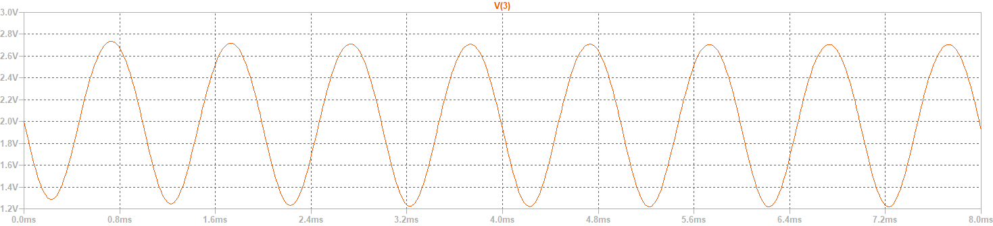

$V_{2}$: 7.98V - 6.58V = 1.4V

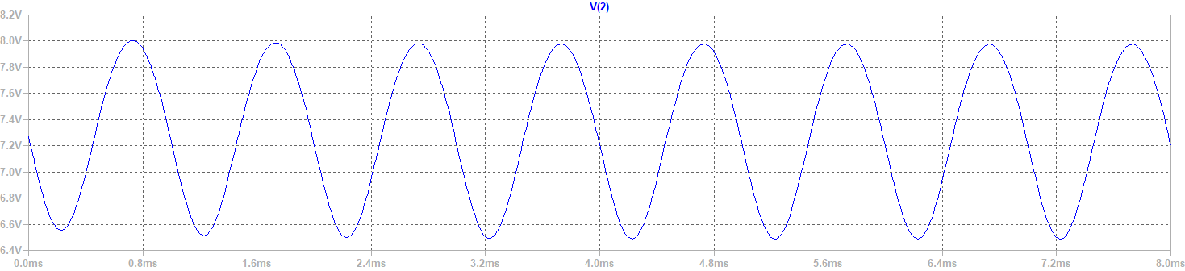

$V_{1}$: 1.658V - 1.647V = 0.011V

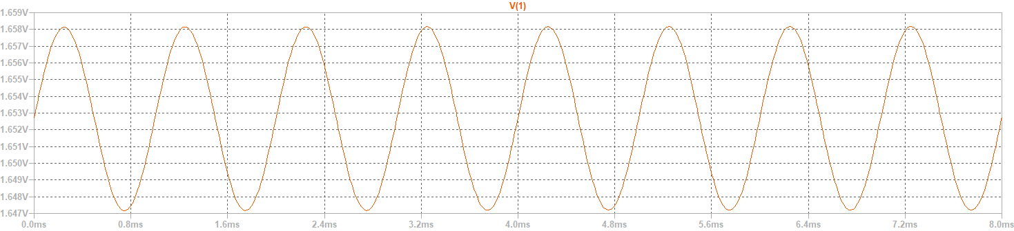

|  |  |  |  |  |
| --- | --- | --- | --- | --- |
| Simulation | $$V_{1}$$ | $$V_{2}$$ | $$V_{3}$$ | $$V_{4}$$ |
| VPP | 0.011V | 1.4V | 1.4V | 6.78V |

$A_{V1}$ = $\frac{V_{2}}{V_{1}}= \frac{1.4V}{0.011V}=$ 127.27 V/V;

$A_{V2}$ = $\frac{V_{4}}{V_{3}}= \frac{6.78V}{1.4V}$ = 4.84V/V;

$A_{V}$ = $\frac{V_{4}}{V_{1}}= \frac{6.78V}{0.011V}$ = 616.36V/V

Q: Is $A_{V}= A_{V1}× A_{V2}$?

A: YES.

127.27 $×4.84=616.35 ≅616.36$

Q: Is

A: YES.

* 1. = 1.4

Q: Compare (a) and (b), parallel connect a capacitor on CE amplifier would make the gain increase or decrease?

A: Increase. The total gain AV increase from 16.12 to 616.36 .

1. Observation and discussion

Observation:

The RC-coupled amplifier is an amplifier in which the AC voltage signal generated by the load resistor of the previous stage is transmitted to the next stage through a coupling capacitor. Therefore, it is called a resistor-capacitor coupled amplifier.

The AC signals are transmitted between stages through coupling capacitor. The coupling capacitors effectively act as open circuits for DC, isolating the DC bias voltages of each stage. For AC, the coupling capacitors act as short circuits, allowing the AC signals to be amplified and transmitted between stages.

The RC-coupled cascaded amplifier uses the same circuit for both the first and second stages. Since capacitors act as open circuits under DC voltage, the DC bias voltages of each stage are isolated and do not affect each other. This design provides advantages such as stable DC operating points and ease of biasing. However, RC-coupled amplifiers also have disadvantages, such as poor low-frequency response due to the decreasing capacitive reactance and increasing impedance at lower frequencies.

Discussion:

Q: Why the voltage gain AV1 in practical with 100uF capacitor on T $R_{1}$ difference from the simulation result, which is 82.14 compare to 127.27?

A: Since both measurement’s and simulation’s V1 are small (0.0168V and 0.011V), and that AV1 is defined as $\frac{V_{2}}{V_{1}}$, it is reasonable that measurement’s and simulation’s AV1 differ that much. If we just look at the peak-to-peak voltage of V1, then the difference would be acceptable.

1. Working Project #2: Direct-coupled amplifier circuit
2. Measurement Data
3. With 100uF capacitor on T $R_{2}$

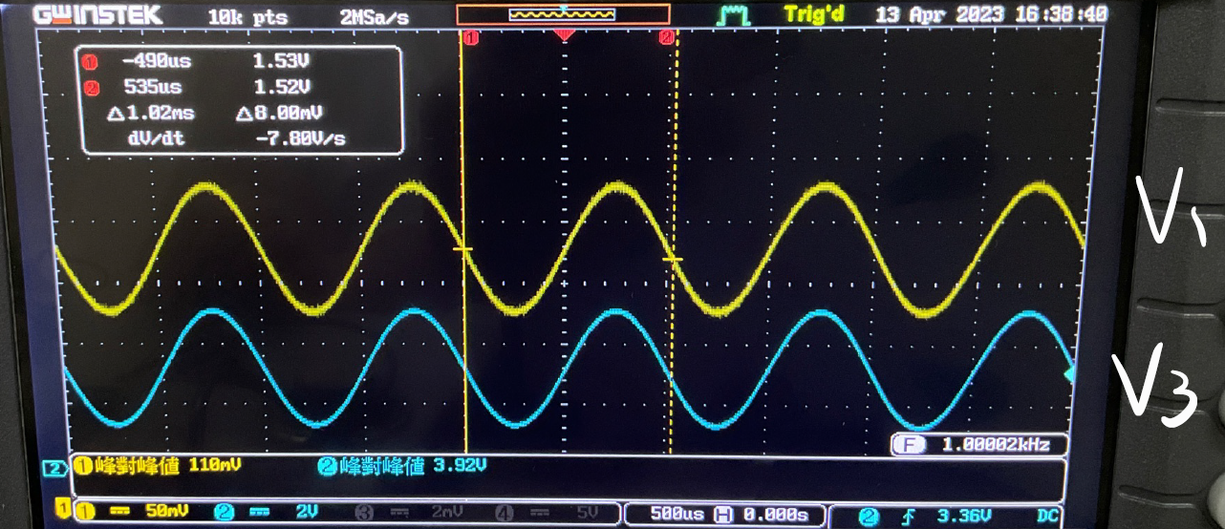

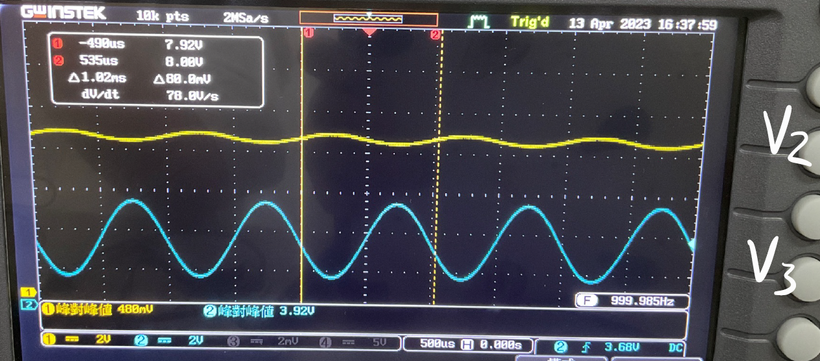

|  |  |  |  |
| --- | --- | --- | --- |
| Measurement | $$V_{1}$$ | $$V_{2}$$ | $$V_{3}$$ |
| VPP | 0.110V | 0.400V | 3.92V |

$A_{V1}$ = $\frac{V_{2}}{V_{1}}= \frac{0.400V}{0.110V}=$ 3.636V/V;

$A_{V2}$ = $\frac{V_{3}}{V_{2}}= \frac{3.92V}{0.400V}$ = 9.8V/V;

$A_{V}$ = $\frac{V_{3}}{V_{1}}= \frac{3.92V}{0.110V}$ = 35.6363V/V

Q: Is $A_{V}= A_{V1}× A_{V2}$?

A: Approximately YES.

3.636 $×9.8=366.097≈371.42$

1. Without 100uF capacitor on T $R_{2}$

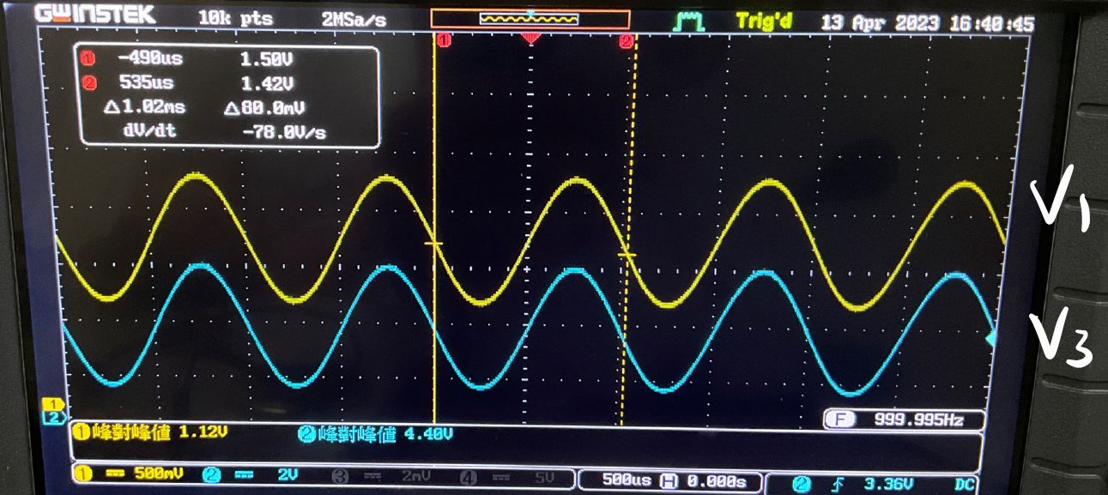

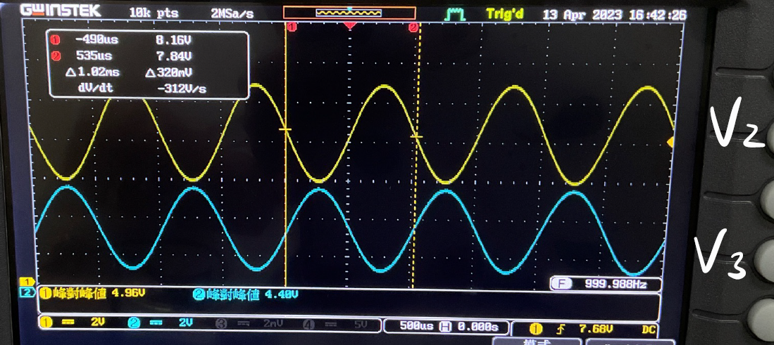

|  |  |  |  |
| --- | --- | --- | --- |
| Measurement | $$V_{1}$$ | $$V_{2}$$ | $$V_{3}$$ |
| VPP | 1.12V | 4.96V | 4.48V |

$A_{V1}$ = $\frac{V_{2}}{V_{1}}= \frac{4.96V}{1.12V}=$ 4.428V/V;

$A_{V2}$ = $\frac{V_{3}}{V_{2}}= \frac{4.48V}{4.96V}$ = 0.90V/V;

$A_{V}$ = $\frac{V_{3}}{V_{1}}= \frac{4.48V}{1.12V}$ = 4V/V

Q: Is $A_{V}= A_{V1}× A_{V2}$?

A: Approximately YES.



$×0.90=3.978≈4$

Q: Compare the result of step5 and step9, tell the difference.

A: V2 and V1 in step9 are significantly larger the V2 and V1 in step5

1. Simulation Result
2. With 100uF capacitor on T $R_{2}$

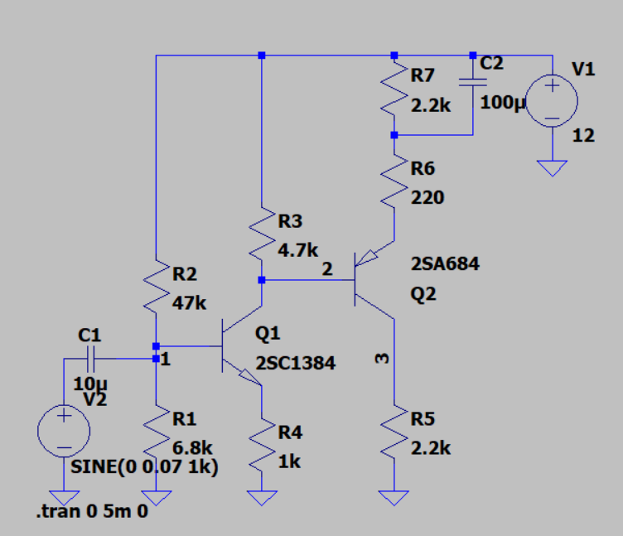

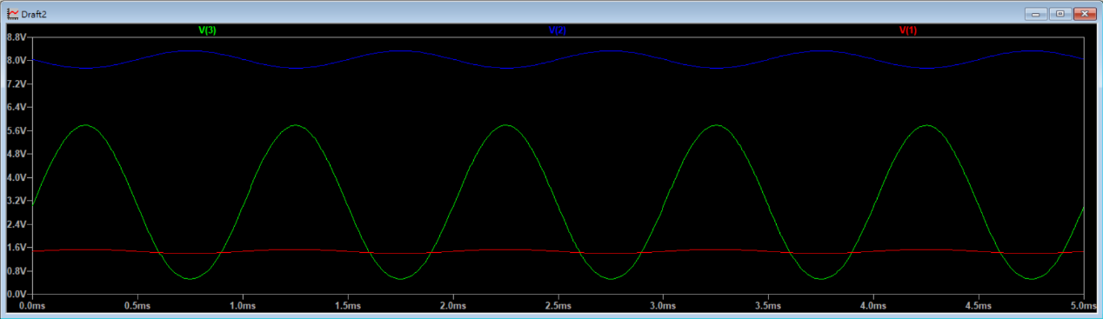

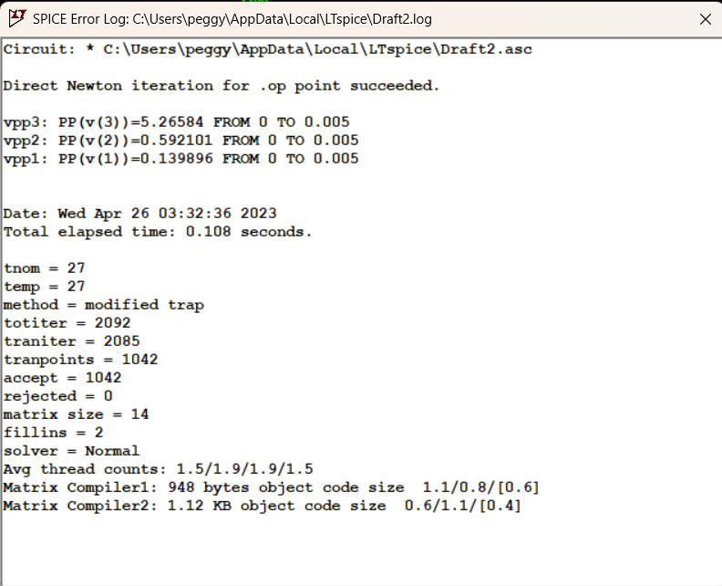

|  |  |  |  |
| --- | --- | --- | --- |
| Simulation | $$V_{1}$$ | $$V_{2}$$ | $$V_{3}$$ |
| VPP | 0.139896V | 0.592101V | 5.2654V |

$A_{V1}$ = $\frac{V_{2}}{V_{1}}= \frac{0.592101V}{0.139896V}=$ 4.232V/V;

$A_{V2}$ = $\frac{V_{3}}{V_{2}}= \frac{5.2654V}{0.592101V}$ = 8.892V/V;

$A_{V}$ = $\frac{V_{3}}{V_{1}}= \frac{5.2654V}{0.139896V}$ = 37.637V/V

Q: Is $A_{V}= A_{V1}× A_{V2}$?

A: YES.

$4.2324×8.8927=37.637$

1. Without 100uF capacitor on T $R_{2}$

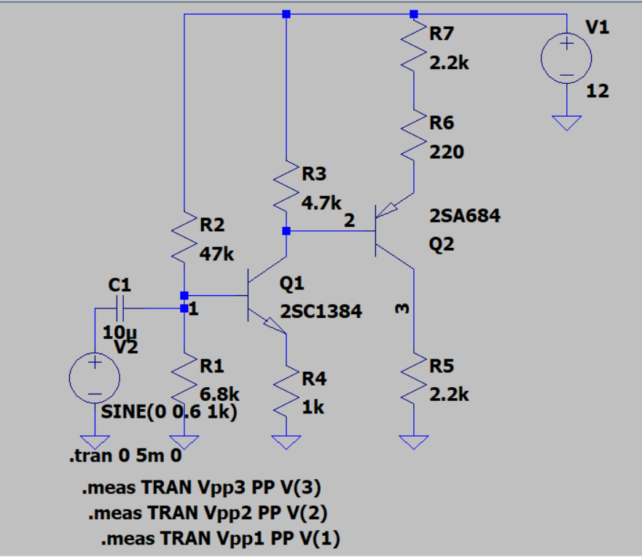

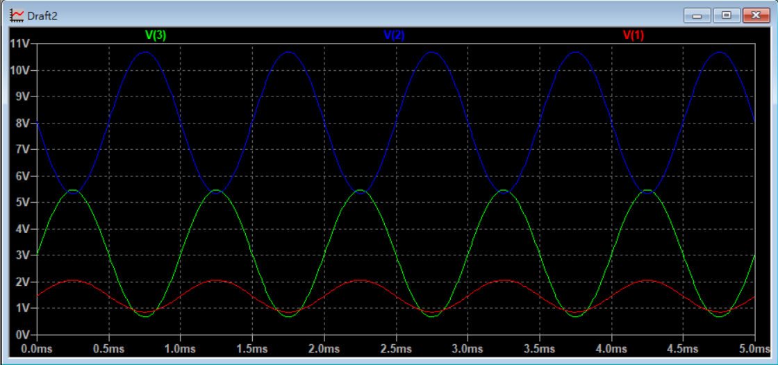

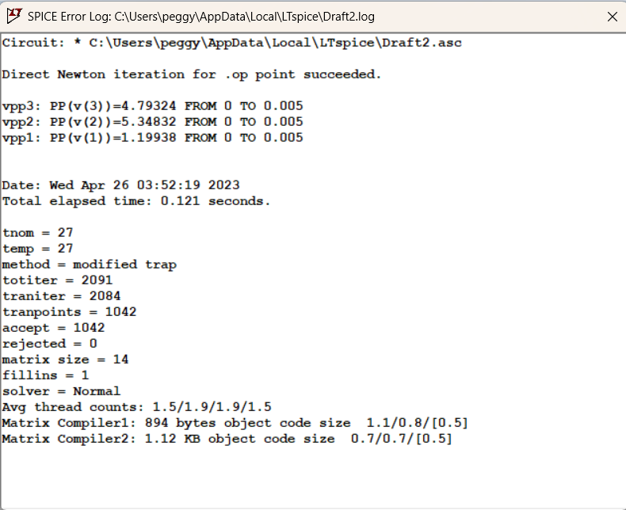

|  |  |  |  |
| --- | --- | --- | --- |
| Simulation | $$V_{1}$$ | $$V_{2}$$ | $$V_{3}$$ |
| VPP | 1.19938V | 5.34832V | 4.79324V |

$A_{V1}$ = $\frac{V_{2}}{V_{1}}= \frac{5.34832V}{1.19938V}=$ 4.459V/V;

$A_{V2}$ = $\frac{V_{3}}{V_{2}}= \frac{4.79324V}{5.34832V}$ = 0.896V/V;

$A_{V}$ = $\frac{V_{3}}{V_{1}}= \frac{4.79324V}{1.19938V}$ = 3.996V/V

Q: Is $A_{V}= A_{V1}× A_{V2}$?

A: Approximately YES.

$4.459×0.896=3.995≈3.996$

Q: What is the difference of V3 after removing out the100uf capacitor from TR2?

A: V3 decreased.

Before adjust:

|  |  |  |
| --- | --- | --- |
|  | V3(V):without capacitor | V3(V):with capacitor |
| Simulation | 0.563931 | 5.2654 |
| Measurement | 0.56 | 3.92 |

* V3 become smaller

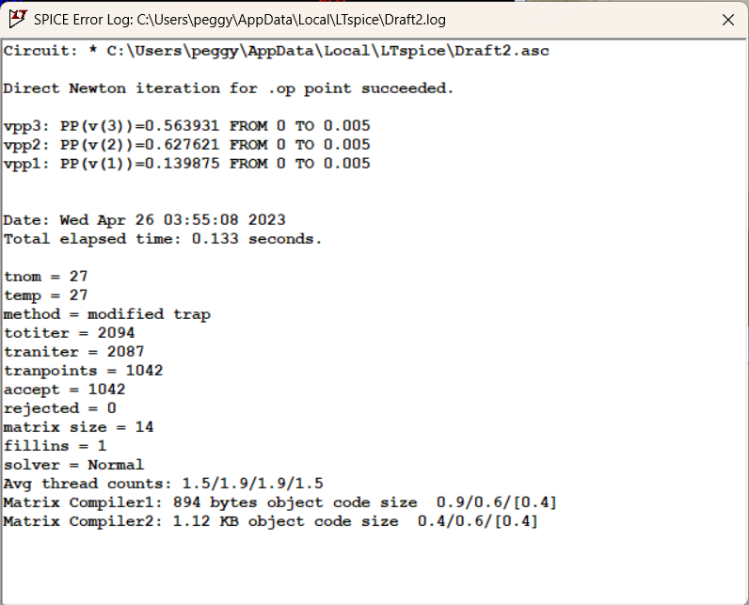

Q: Compare the result of step5 and step9, tell the difference.

A: V2 and V1 in step9 are significantly larger the V2 and V1 in step5

1. Observations and Discussions

In the same fashion of analysis as lab1, the lab2 circuit should be analyzed from the output terminal with the consideration of load effect. However, there’s no additional capacitor between the two one-stage amplifier circuits comparing to lab1, which allows the low-frequency signal to be appropriately amplified. Further, the capacitor parallel to the resistor at the emitter of the PNP transistor allows the 12V power supply to directly be transferred to the second resistor, thus, V3 decreases.

1. Practice Problems

1. What is the function of coupled?

A: Single one-stage amplifier is not able to amplify a signal by a large enough gain, while it cascaded with more amplifier is.

2. What’s the normal way of coupling?

A: two-stage RC coupling, direct coupling, transformer coupling

3. What’s the disadvantage of RC coupled circuits?

A: a capacitor is set at the middle of the amplifier circuits, which blocks the low-frequency signal and affects the it’s frequency response.

4. What’s the disadvantage of transformer coupled circuits?

A: relatively worse frequency response, more significant distortion, heavier

5. What is the frequency when the speaker works at the indicated impedance?

A: 1kHz, the corresponding impedance changes with the imported frequency.

6. For a transformer with the ratio of the number of turns is 10:1, when a 8ohm impedance is loaded in the secondary side, what’s the equivalent impedance on the primary side?

A: 800ohm, equivalent impedance of the secondary side referred to the primary side is 8*(10/1)^2

7. For the circuit shown in Fig.11-7, what’s the minimum tolerance of the transistor should be when Vcc=12V? Why?

A: 24V, the tolerance of the transistor should be higher than two times of Vcc

1. Reflection

In the experiment, we implemented three types of cascade amplifiers, including RC-coupled amplifiers, direct-coupled amplifiers, and transformer-coupled amplifiers. As the single BJT amplifier has low voltage gain, cascade amplifiers are needed. All of these circuits were able to successfully amplify input signals during the experiment, and we calculated the peak-to-peak voltage and voltage gain at four points to understand their amplification effects.

In terms of the three types of cascade amplifiers, RC-coupled amplifiers have advantages such as stable operating point, easy biasing design, but they also have disadvantages such as higher power loss in resistive load, difficulty in matching input and output impedance of stages, and poor low-frequency and high-frequency response.

Direct-coupled amplifiers have the advantages of simple circuit structure, low cost, and optimal low-frequency response, but the disadvantages are unstable static operating point and difficulty in matching input and output impedance of stages.

Transformer-coupled amplifiers have the advantages of achieving impedance matching between stages and improving power transfer efficiency, but the disadvantages are susceptibility to magnetic field interference, higher cost and larger volume of transformers, and poorer frequency response of the amplifier.

In addition, in the experiment, we also tested the audio frequency transformer to calculate the primary winding impedance, which serves as a preparatory work for the subsequent transformer-coupled amplifier experiment. This experiment was very helpful for us to gain a deeper understanding of transformer characteristics and applications.

Finally, we found the experiment involving the speaker in working project 4 to be interesting, as it allowed us to hear the amplified sound effects and further understand the applications and effects of amplifiers.

We would like to thank the teaching assistant and our team members for their cooperation and assistance during the experiment, which allowed us to successfully complete the experiment and gain valuable experimental insights and experiences.